Theory of low-frequency electron fluctuations in a quasi-ballistic FET

M. Yelisieiev¹ and V. A. Kochelap¹
1)Institute of Semiconductor Physics, NAS of Ukraine, Kyiv, Ukraine
Scaling down electronic devices requires studies of physics of nonequilibrium electron transport under highly nonuniform self-consistent electric fields in nanostructures. At that, a relevant theory is a key element of these studies. Here we report theoretical results on physics of nanoscale field effect transistors (FETs), which is a basic device of nanoelectronics. Our main goal was to investigate the electronic processes in a FET channel using shallow water approximations [1] to obtain the analytical expressions for electron and field distributions, as well as electric fluctuations using the Langevin approach [2]. We considered the current-voltage characteristic of the transistor in the stationary mode. For the non-stationary case, we obtained the spatial distributions of the spectral fluctuations density for different parameters of the channel, and the dependence of these values on the stationary parameters We considered two modes of measuring transistor characteristics, with a fixed voltage (A) or current (B), and, correspondingly, suppressed fluctuations of either of these two quantities.
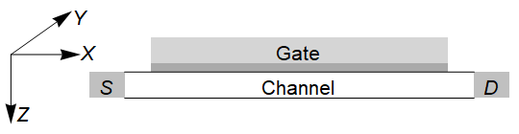
Fig. 1. The schematical view of the device we studied
In the shallow water approach, the equation of motion for the electrons takes the following form:
$\frac{dn}{dξ}=B\frac{ζ n^{2}}{ \left[ζ^{2} - n^{3}\right]}$, $B={\left(\frac{m ε { ε}_{0}}{e^{2}h }\right)}^{1/3}\frac{ L }{τ J^{1/3}}$, $ζ=\frac{j_{0}}{J}$, $A=\sqrt[3]{\frac{m ε { ε}_{0}}{e^{2}h }}J^{2/3}$, where $n=\frac{n}{A}$, and $ξ=\frac{x}{L}$ (1)
Here $n$ is the concentration, $L$ is the channel length, $h$ is the substrate thickness, and $m$ and $e$ are the effective mass and charge. $A$ is a constant, and $B$ is the low-bias resistance of the channel. For the case of Langevin sources $F^{'}\left(x\right)$ of fluctuations [2] in the channel, we solve the linearized dynamic equation (2), assuming that the frequency of fluctuations is less than the inverse time of free passage of electrons through the device.
$\left(\frac{j_{0}}{n_{0}}-\frac{e^{2}h}{m ε{ ε}_{0}}\frac{n_{0}^{2}}{j_{0}}\right)\frac{du^{'}}{dx}+u^{'}\frac{1}{τ}-\left[\frac{e^{2}h}{m ε{ ε}_{0}}2\frac{n_{0}}{j_{0}}+\left(\frac{j_{0}}{n_{0}^{2}}\right)\right]\frac{dn_{0}}{dx}u^{'}=F^{'}\left(x\right)$ (2)
The noise characteristics are shown on Figs. 2 and 3.
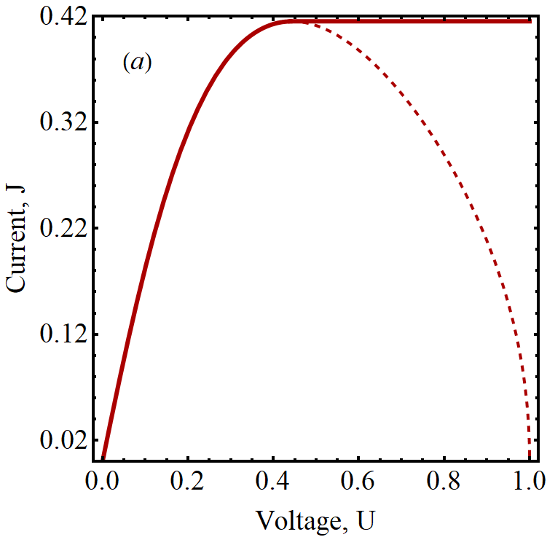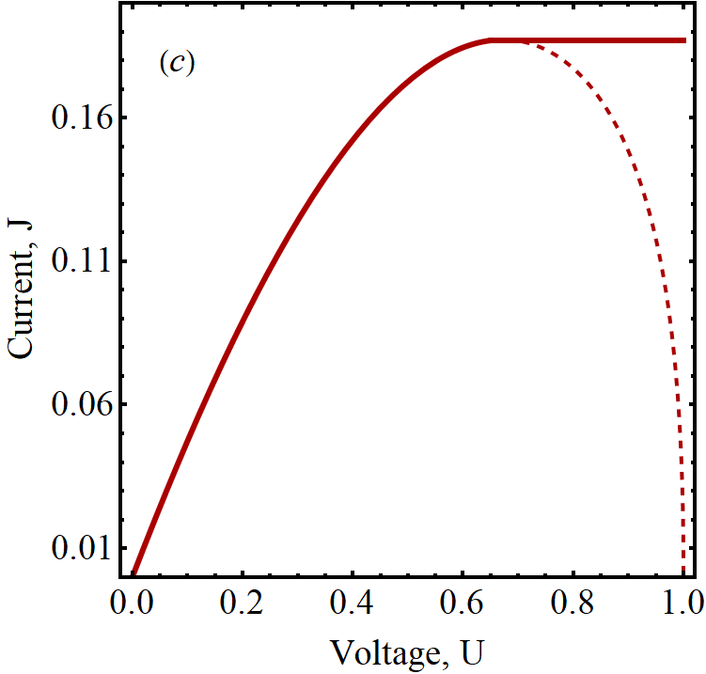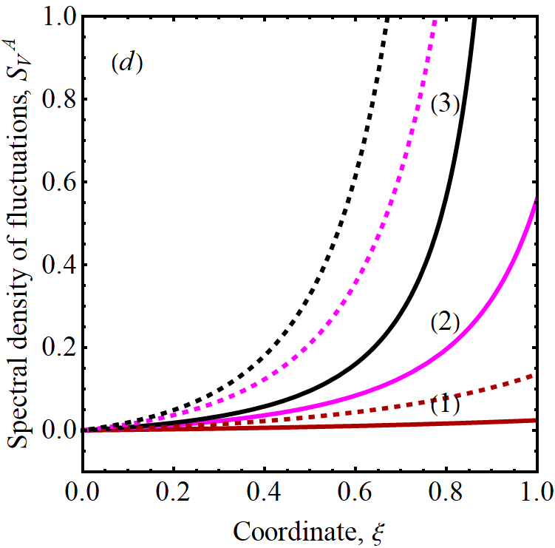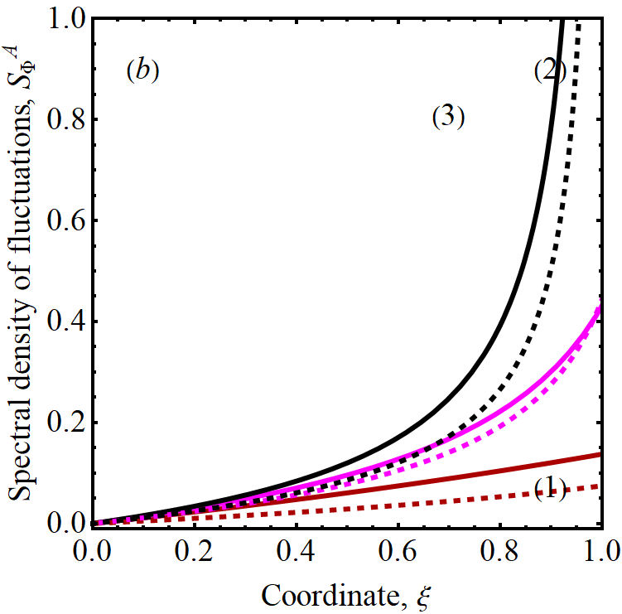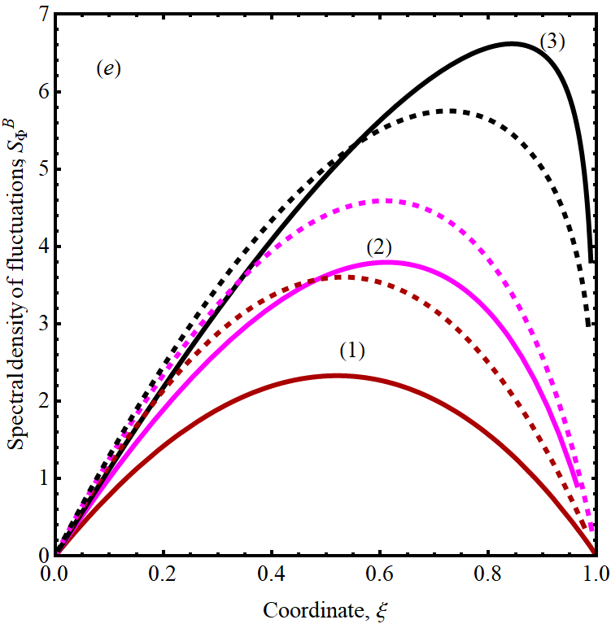
Fig. 2. Dimensionless characteristics of quasi-ballistic FETs for B = 0:5; J_{c} = 0:415, panels (a), (b), and B = 2, J_{c} = 0:187, panels (c), (d). (a), (b): I-V characteristics; current saturation portions are shown conditionally. (c), (d): Spatial distributions of the fluctuations of the velocity and local potential. (e): Local potential distribution in mode B.
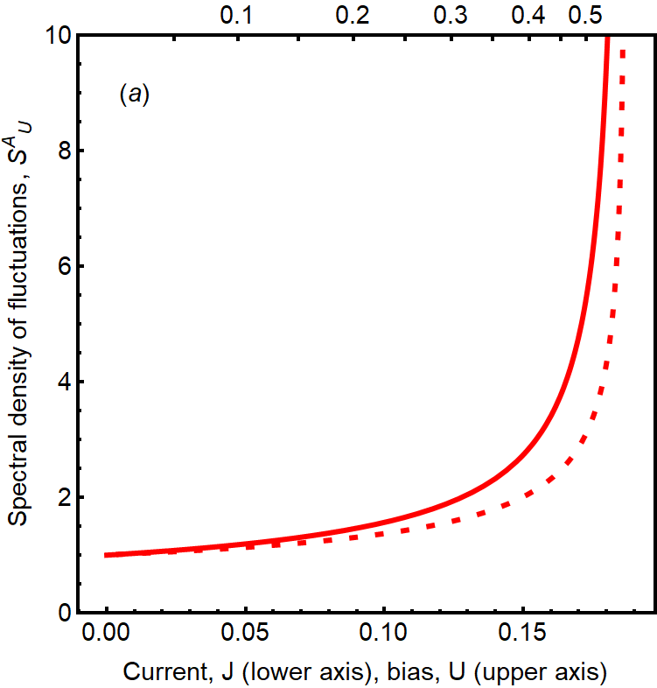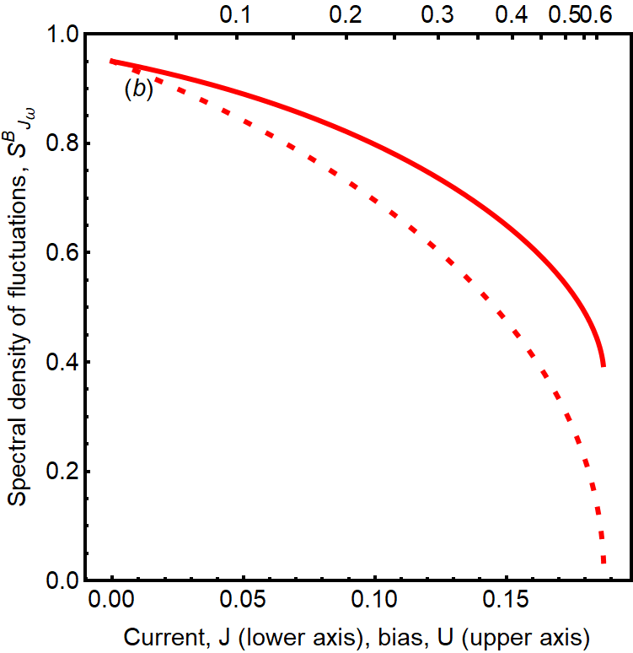
Fig. 3. The spectral densities of voltage and current fluctuations in FET (full lines). (a): ${S^{A}}_{U}$f or the circuit A; (b): ${S^{B}}_{J_{ω}}$ for the circuit B, for B = 2. Dotted lines are relevant estimates with the use of the differential resistance, and the Nyquist formula.
Thus, we were able to obtain the analytical expressions for various stationary and noise characteristics of a FET, solving a non-linear equation system. We used some approximations and a linear approach in the process, in order to solve the dynamic equations in the low-frequency case. We compared our results with the Nyquist formula [2], as well. We discuss contemporary methods of nanoscale measurement of predicted results. These results are available in the preprint [3].
[1] L. D. Landau, E. M. Lifshitz, Statistical Physics. v. 5 of Course
of Theoretical Physics, Elsevier, 1980.
[2] Kogan Sh., Electronic Noise and Fluctuations in Solids // Cambridge University Press, 1996
[3] Yelisieiev M., Kochelap V, // arXiv:2211.10697, 2022.

