TUNNEL MAGNON TRANSFER THROUGH A FERROMAGNETIC CHAIN

S.M. Tunyk, E.G. Petrov
Bogolyubov Institute for Theoretical Physics, Nat. Acad. Sci. Ukr Kyiv, Ukraine
e-mail: toonik@ukr.net

In connection with the development of quantum technologies, special attention has been paid to the study of quantum properties of hybrid systems based on magnonics [1]. One of the areas of use of magnons (spin excitations) may be related
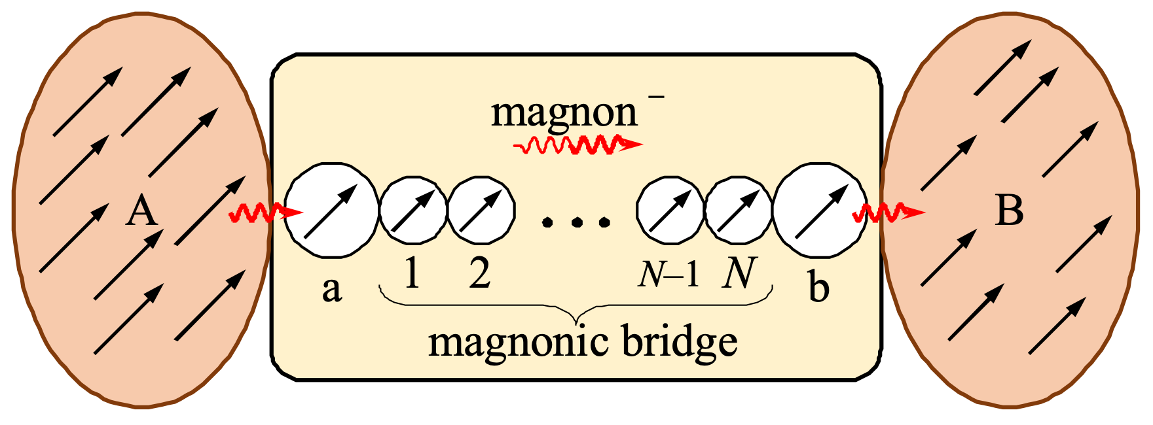
Fig. 1
to transfer of information The development of quantum information technologies has shown that charged particles are not very convenient for transmitting information. T
Fig. 2
This is due to the Joule heat that is released in the device during the transport of t
charge. Therefore, uncharged carriers are most suitable for transmitting information over nanoscale distances. It is proposed to use spin excitations of ordered paramagnetic ions as these. Since the motion of magnons can be controlled by both a magnetic field (acting on the magnetic moment of the paramagnetic ion) and an electric field (through deformation of the crystal field of the ligands), this makes magnons suitable for use in quantum communications. It is also known that magnons interact quite well with phonons and photons – respectively, quanta of oscillations of atomic nuclei and quanta of the electromagnetic field. Based on this fact, it was possible to create hybrid devices that are microcavities with nanomagnets inserted into them. In such hybrid photon-magnon resonators, electromagnetic oscillations occur with frequencies of the order of gigahertz and terahertz, which also corresponds to the excitation frequencies of static (Kitel's) magnons. This opens up wide opportunities for generating one type of excitation quanta into quanta of another type for the purpose of using hybrid photon-magnon resonators in quantum technology. In the work [2] a physical mechanism for implementing quantum communication between photon-magnon resonators is proposed, according to which magnons generated in the nanomagnet of one of the resonators (A or B) can be transferred to the other resonator through ferromagnetic nanoscale chains (see Fig. 1). Such transfer can be carried out in two ways, namely by sequential magnon hoppings along all units of the chain, as well as by magnon tunneling between its terminal units a and b. Here we present the results of theoretical studies of the dependence of rate K_{tun} (~R(N,α)) of non-resonant (Fig. 2a) and resonant (Fig. 2b) tunneling of a magnon between nanomagnets A and B connected by a ferromagnetically ordered chain of N identical units. In the non-resonant tunneling mode, an exponential decrease in rate is clearly visible with increasing N. The situation changes dramatically in the case of resonant tunneling. In the non-resonant tunneling mode, an exponential decrease in rate is clearly visible with increasing N. The situation changes dramatically in the case of resonant tunneling. One can see significant changes in rate at certain values ​​of the spin excitation energy entering the chain. In fact, these values ​​will coincide with the broadened magnon energies in the chain. Thus, the tunneling transport of magnons through bridging ferromagnetic structures indicates a specific coherent mechanism for implementing quantum communications using uncharged carriers. Switching the tunneling mode of magnons by a magnetic field can be considered as an effective tool for controlling the transfer of information between ferromagnetic nanocenters.

[1] D. Lachance-Quirion, Yu. Tabuchi, A. Gloppe, K. Usami, Ya. Nakamura,
J. Appl. Phys. Express 12, 070101(2019).
[2] E. G. Petrov, J. Appl. Phys. 135, 134301(2024)/

